Course Name: | Web Development Laboratory (316U01L306) | Semester: | III
Date of Performance: | 10/10/26 | DIV/ Batch No: | A1
Student Name: | Mrudul Bhagwat | Roll No: | 20

Experiment No: 4&5
Title
Form Validation using JavaScript for an AI-based Smart Irrigation Advisory Web Portal
Aim of the Experiment
To design and implement client-side form validation using JavaScript for the farmer registration form of an AI-based Smart Irrigation Advisory System, ensuring that user-entered data such as name, mobile number, email, plot ID, soil moisture, crop stage, irrigation method, and date is complete, valid, and meaningful before form submission.
Objectives of the Experiment
• To create an interactive HTML form for collecting farmer and farm information.
• To use JavaScript to validate text, numeric, email, date, and selection fields.
• To implement regular expressions for validating mobile numbers, email addresses, and plot IDs.
• To display meaningful error messages and prevent submission when invalid data is entered.
• To apply form validation to a real-world agriculture use case involving farmer and farm registration.
COs to be achieved
CO1: Developing webpages using HTML, CSS and JavaScript.
Books / Journals / Websites references
1. MDN Web Docs – JavaScript Guide and HTML Forms.
2. W3schools.com
3. JavaScript documentation/reference material prescribed by the course instructor.
Theory
Form validation is the process of checking whether the information entered by a user satisfies the required rules before it is submitted or processed. Validation improves data quality, usability, and reliability of web applications.
JavaScript provides client-side validation by accessing form elements through the DOM and checking their values using conditions, string methods, numeric comparisons, regular expressions, and event handlers such as submit and input. If invalid data is detected, JavaScript can display an error message and stop the form from being submitted.
Common validation rules include checking for empty fields, minimum and maximum length, valid email format, valid mobile number, acceptable numeric ranges, selected options, and valid dates. Regular expressions are useful for validating structured values such as mobile numbers and email addresses.
The deployed KisanSaathi portal includes a farmer registration page for collecting personal and farm details. The implementation and observed behavior below were checked against the live page; requested rules that are absent from the current code are identified as gaps.
Problem Statement
"JavaScript Form Validation for Farmer Registration"
Develop a web-based farmer registration form for the Smart Irrigation Advisory System. The form should collect essential farmer and farm information and use JavaScript to validate the entered values before submission. Invalid or incomplete data must be identified and appropriate error messages must be displayed to the user.
Task 1: Create the Farmer Registration Form
Scenario
Design a registration form for farmers who will use the Smart Irrigation Advisory System.
Requirements
• Create fields for Farmer Name, Mobile Number, Email, Plot ID, Village, Crop Stage, Soil Type, Irrigation Method, Soil Moisture (%), Registration Date and Farm Photo.
• Use <form>, <label>, <input>, <select>, <option>, <fieldset> and <legend>.
• Provide Submit and Reset buttons.
• Assign unique id and name attributes to all fields.
Concepts Tested
• HTML Forms
• Form controls
• DOM element identification
Deliverable: registration.html
Task 2: Validate Required Text Fields
Scenario
Ensure that essential farmer and farm information is not left blank.
Requirements
• Check that Farmer Name, Plot ID and Village are not empty.
• Remove leading and trailing spaces using trim().
• Validate that Farmer Name contains alphabetic characters and spaces only.
• Display an error message beside each invalid field.
Concepts Tested
• JavaScript conditions
• String methods
• Required-field validation
Deliverable: registration.html
Task 3: Validate Mobile Number and Email
Scenario
Verify that the farmer's contact information follows the expected format.
Requirements
• Validate a 10-digit Indian mobile number using a suitable regular expression or any other rule.
• Validate the email address.
• Display specific messages for invalid mobile number and email.
• Do not allow the form to submit until both fields are valid.
Concepts Tested
• Regular expressions
• String validation
• Form submit event
Deliverable: registration.html
Task 4: Validate Selection and Date Fields
Scenario
Ensure that the farmer provides valid crop, soil, irrigation and date information.
Requirements
• Ensure that Crop Stage, Soil Type and Irrigation Method are selected.
• Validate that Registration Date is entered.
• Prevent future registration dates if the application rule requires the registration date to be today or earlier.
• Highlight the field when validation fails.
Concepts Tested
• Select validation
• Date validation
• DOM manipulation
Deliverable: registration.html

Code : GitHub Repository :https://github.com/mrudul2505/AI-based-Smart-Irrigation-Advisory-Kisan-Sathi-
document.addEventListener('DOMContentLoaded', () => {
const form = document.getElementById('registration-form');
const today = new Date().toISOString().split('T')[0];
const dateInput = document.getElementById('date');

dateInput.max = today;

const rules = {
name: value => {
const trimmed = value.trim();
if (!trimmed) return 'Name is required.';
if (!/^[A-Za-z ]+$/.test(trimmed)) return 'Enter a name using letters and spaces only.';
return '';
},
mobile: value => {
const trimmed = value.trim();
if (!trimmed) return 'Mobile number is required.';
if (!/^[6-9]\d{9}$/.test(trimmed)) return 'Enter a valid 10-digit Indian mobile number.';
return '';
},
email: value => {
const trimmed = value.trim();
if (!trimmed) return 'Email address is required.';
if (!/^[^\s@]+@[^\s@]+\.[^\s@]+$/.test(trimmed)) return 'Enter a valid email address.';
return '';
},
village: value => value.trim() ? '' : 'Village is required.',
plotid: value => value.trim() ? '' : 'Plot ID is required.',
cropstage: value => value ? '' : 'Select a crop stage.',
soiltype: value => value ? '' : 'Select a soil type.',
irrigation: () => document.querySelector('input[name="irrigation"]:checked') ? '' : 'Choose an irrigation method.',
moisture: value => value !== '' ? '' : 'Soil moisture is required.',
date: value => {
if (!value) return 'Date is required.';
if (value > today) return 'Registration date cannot be in the future.';
return '';
}
};

function setFieldState(id) {
const input = document.getElementById(id);
const message = rules[id](input ? input.value : '');
const error = document.getElementById(`${id}-error`);
const targets = id === 'irrigation'
? document.querySelectorAll('input[name="irrigation"]')
: [input];
targets.forEach(target => {
target.classList.toggle('is-invalid', Boolean(message));
target.setAttribute('aria-invalid', Boolean(message));
});
error.textContent = message;
return !message;
}

Object.keys(rules).forEach(id => {
const input = document.getElementById(id);
if (input) {
input.addEventListener('input', () => setFieldState(id));
input.addEventListener('change', () => setFieldState(id));
}
});
document.querySelectorAll('input[name="irrigation"]').forEach(input => input.addEventListener('change', () => setFieldState('irrigation')));

form.addEventListener('submit', event => {
event.preventDefault();
const valid = Object.keys(rules).every(setFieldState);
const success = document.getElementById('form-success');
success.hidden = !valid;
if (valid) {
success.textContent = 'Registration details are valid. Farmer registration is ready to be submitted.';
} else {
success.hidden = true;
form.querySelector('.is-invalid')?.focus();
}
});

form.addEventListener('reset', () => {
window.setTimeout(() => {
document.querySelectorAll('.field-error').forEach(error => error.textContent = '');
document.querySelectorAll('.is-invalid').forEach(input => input.classList.remove('is-invalid'));
document.getElementById('form-success').hidden = true;
});
});
});
Output / Screenshot:
The following screenshots were captured directly from the deployed registration page at https://smartirrigation-brown.vercel.app/registration.html. They show the empty form, actual inline validation errors, and the ready-to-submit status after entering sample values.
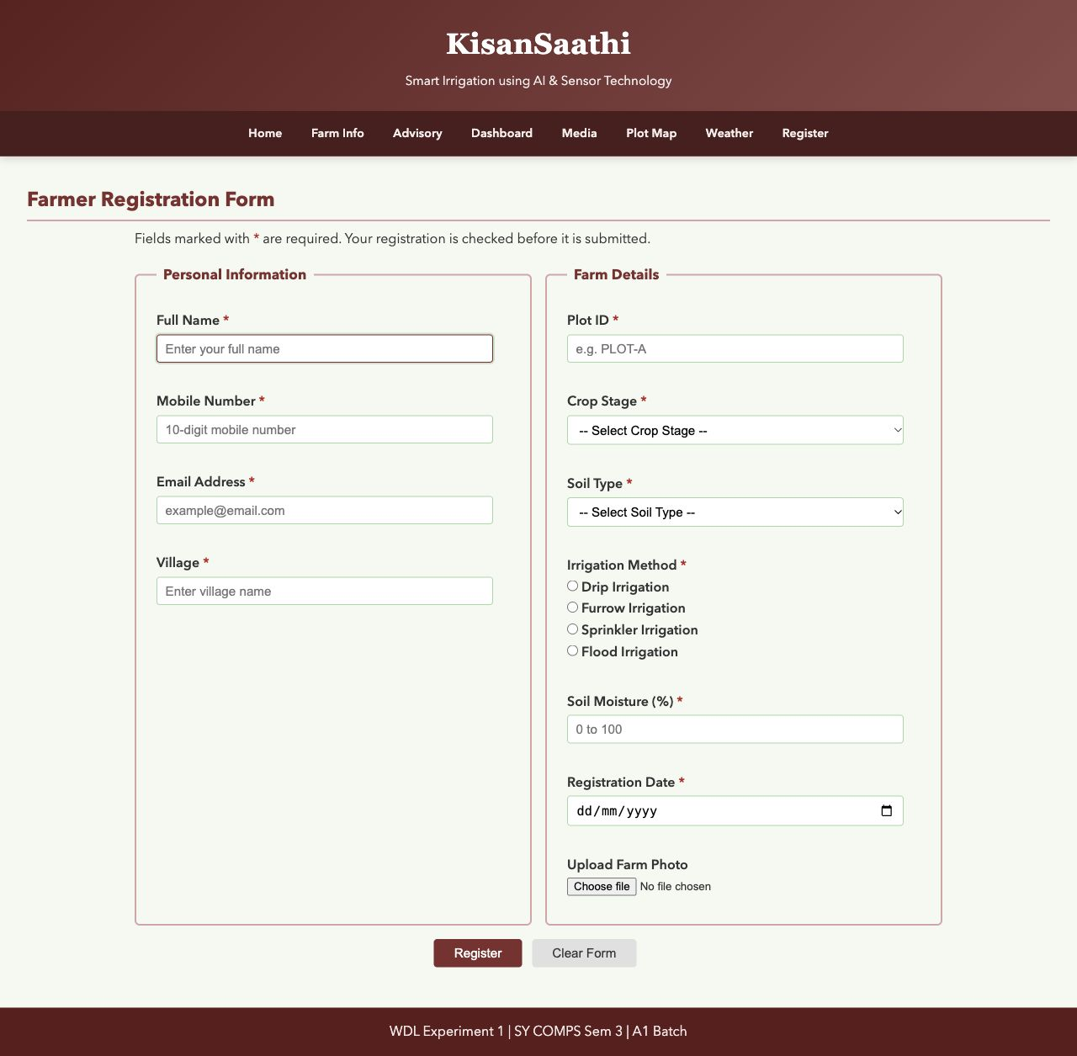
Figure 1 Live farmer registration form before data entry.
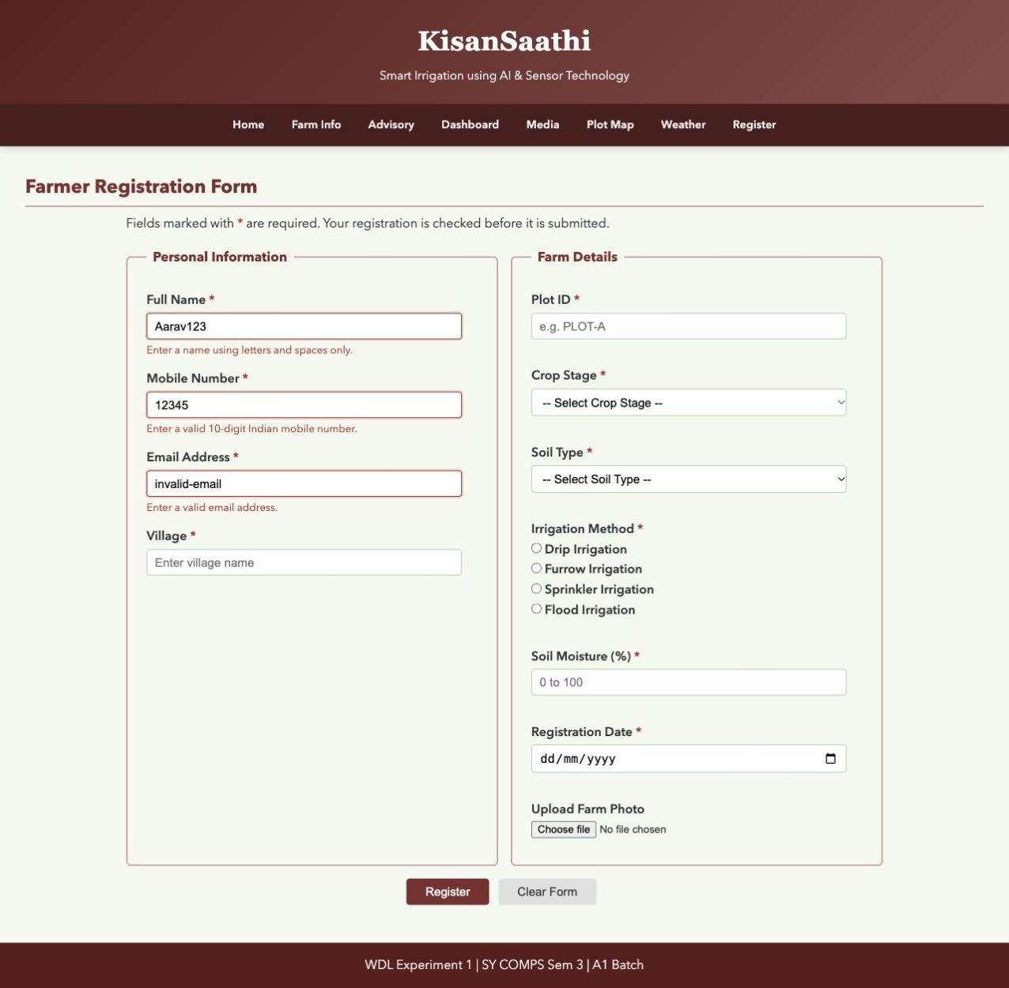
Figure 2 Invalid sample name, mobile number and email produce inline error messages.
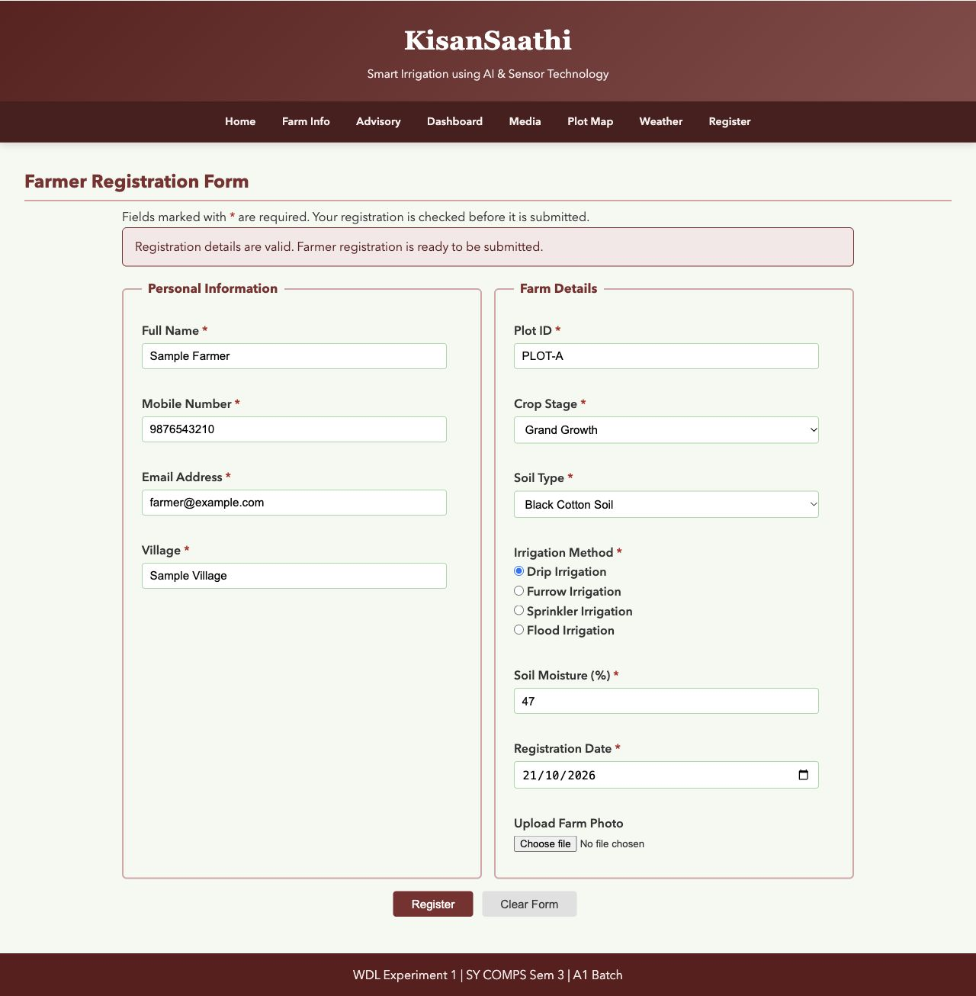
Figure 3 Valid sample values produce the ready-to-submit message. This is a client-side status, not a saved server registration.
Conclusion and Discussion:
The deployed JavaScript validates required values, name characters, Indian mobile format, email format, crop stage, soil type, irrigation method, and registration date. It highlights invalid controls, shows inline messages, clears messages on reset, and displays a client-side ready message for values that pass. The form prevents the default submit action; this implementation does not send registration data to a server.

